**NUTRICARE**



#### Bachelor of Science (Computer Science) Session (2019-2023)

**Submitted By**:

|  |  |
| --- | --- |
| **Name** | **Roll Number** |
| **Abdullah Hassan** | **2019f-mulbscs-070** |

**SUPERVISOR**

Hafiz Muhammad Usama

**DEPARTMENT OF COMPUTER SCIENCE AND**

**INFORMATION TECHNOLOGY MINHAJ UNIVERSIT LAHORE, PAKISTAN**

## NutriCare

Rapid Nutritional Consultation Platform

# PROJECT

*Submitted in Partial Fulfillment*

of the Requirements for the Degree of

Bachelor of Science (Computer Science)

At the

### Minhaj University, Lahore

By

ABDULLAH HASSAN

2019F-mulbscs-070

|  |  |
| --- | --- |
| *Mr.Shafiq ur rehman*  Supervisor  School of Computer Science | *Dr. Gulzar Ahmad*  Head School Computer Science |

**DECLARATION**

It is declared that this is an original piece of my own work, except where otherwise acknowledged in text and references. This work has not been submitted in any form for another degree or diploma at any university or other institution for tertiary education and shall not be submitted by me in future for obtaining any degree from this or any other University or Institution. I am the responsible if I do not meet the deadline.

Abdullah Hassan Signature: 2019f-mulbscs-070



# DEDICATION

## To

#### My Mother

*Who always wished and prayed for my success, for supporting and encouraging me to believe in myself, for always sacrificing so much for me.*

#### My Father

*For earning an honest living for us, for supporting and encouraging me to believe in myself.*

#### My teachers

*For her support and best wishes.*

# 

# CERTIFICATE OF APPROVAL

It is certified that the project titled “Multiplayer Battle Arena” carried out by Abdullah hassan, Reg. No., under the supervision of Hafiz Muhammad Usama Minhaj University Lahore, is fully adequate, in scope and in quality, as a final year project for the degree of BS of Computer Science.

Supervisor: --------------------------------

Shafiq Ur Rehman

Lecturer

School of Computer Science Minhaj University Lahore

Internal Examiner 1: -------------------------------

School of Computer Science Minhaj University Lahore

Internal Examiner 2: --------------------------------

School of Computer Science Minhaj University Lahore

FYP Coordinator: --------------------------------

Shafiq Ur Rehman

Lecturer

School of Computer Science Minhaj University Lahore

Head of Department: -----------------------------------

Dr. Gulzar Ahmad

School of Computer Science Minhaj University Lahore

# ACKNOWLEDGEMENT

First of all, we are thankful to Allah almighty, the most beneficial and merciful who gave us the courage and guidance to complete our project. We offer our special praise for our beloved Holy Prophet Hazrat Muhammad (S.A.W) who is the symbol of knowledge and guidance of humanity as a whole. We like to express our special thanks of gratitude to our supervisor Sir Hafiz M.Usama for their support. Her steadfast support of this project was greatly needed and deeply appreciated. Last but not least, no acknowledgement could ever express our obligations to our loving parents for their love, affection, amiable, advices and prayers formy success.

# ABSTRACT

In today's fast-paced and health-conscious world, maintaining proper nutrition is more important than ever. However, navigating the vast amount of information and resources available can be overwhelming. To address this challenge, we present NutriCare, an innovative nutritional consultation and aid platform. NutriCare seamlessly combines the power of generative AI and web technologies to provide a comprehensive solution for users seeking to improve their nutritional habits and overall health.

NutriCare offers a range of features designed to cater to the diverse needs of users. These include user authentication, an AI chatbot for answering nutritional queries, personalized diet plans, human doctor consultations, a supplement store, and a nutrient checker for food. Additionally, the platform includes an admin panel for efficient management, a patient dashboard for personalized health tracking, and a secure payment system integrated with Stripe. The user-friendly and interactive interface ensures an engaging experience for all users.

Our goal with NutriCare is to create a one-stop platform where users can access reliable nutritional advice, professional consultations, and essential health products all in one place. By streamlining these services, NutriCare aims to make it easier for individuals to achieve and maintain a healthy lifestyle. This documentation details the development and features of NutriCare, showcasing our commitment to providing a valuable resource for both patients and healthcare professionals.

Table of Contents

CHAPTER 1 INTRODUCTION 1

* 1. Background 2
  2. Goals and Objectives 2
  3. Gap Analysis 3
  4. Project Plan 3
     1. Work Breakdown Structure 5
     2. Gantt chart 6
     3. Gantt chart 6
  5. Report Outline 6

CHAPTER 2 8

SYSTEM REQUIREMENTS AND SPECIFICATIONS 8

* 1. Purpose 9
     1. Document Conventions 9
     2. Intended Audience 10
  2. Overall Description 10
     1. Service Perspective 10
     2. Service function 10
     3. Product Functions 10
     4. User Classes and Characteristics 11
     5. Assumptions and Dependencies 11
  3. External Interface Requirements 13
     1. User Interfaces 13
     2. Application interface 13
  4. System Features 13
     1. User registration 13
     2. Login/logout 14
     3. Change Profile 15
  5. Other Nonfunctional Requirements 15
     1. Performance Requirements 15
     2. Safety Requirements 15
     3. Software Quality Attributes 16
  6. Other Requirements 16

CHAPTER3 USECASE ANALYSIS 17

* 1. Use Case Model 18

CHAPTER 4 SYSTEM DESIGN 24

System Design 25

* 1. Architecture Diagram 25
  2. Domain Model 26
  3. Class Diagram 28
  4. Activity Diagram 33
  5. State Transition Diagram 34
  6. Component Diagram 37
  7. App Interference 38
     1. Registration panel 38
     2. Interfaces 39
     3. Login as Patient 40

CHAPTER 5

IMPLEMENTATION 46

* 1. Components, Libraries and stubs 46
  2. Deployment Environment 48
  3. Tools and Techniques 48
  4. Best Practices / Coding Standards 49

CHAPTER6 50

TEST AND EVALUATION 50

* 1. Testing and Evaluation 51
  2. Use Case Testing 51
  3. Boundary value analysis 54
  4. Performance testing 55
  5. Stress Testing 57
  6. Improvement 57

References 59

#### List of Figures

Figure1. 1 Work Breakdown Structure 2

Figure1. 2 Gantt chart 3

Figure3. 1 Use Case Model 12

Figure4. 1 Architecture Diagram 19

Figure4. 3 Entity relationship diagram 21

Figure4. 4 Class Diagram 22

Figure4. 5 Sequence Diagram 23

Figure4. 6 Sequence Diagram 24

Figure4. 7 Sequence Diagram 24

Figure4. 8 Sequence Diagram 25

Figure4. 9 Sequence/Collaboration 26

Figure4. 10 Activity Diagram 29

Figure4. 11 Component Diagram 33

Figure4. 12 Web app Interfaces 35

# CHAPTER 1 INTRODUCTION

Basically, in this chapter we introducing the main steps of our project. This introduction contains the background, Goals/Objectives, Solutions, Gap Analysis, Gantt chart, Project Plan, Report outline. This material of introduction helps to understand the main issues related to this project.

#### Background:

In today's fast-paced world, maintaining a healthy lifestyle and proper nutrition can be challenging. People often struggle to find reliable sources for nutritional advice, manage their diets, and purchase necessary supplements. Additionally, getting timely consultations with healthcare professionals can be difficult. To address these issues, we have developed NutriCare, a comprehensive nutritional consultation and aid platform.

NutriCare leverages the power of generative AI and web technologies to provide users with a holistic solution for their nutritional needs. Our platform combines various features, including AI-driven chatbots, human doctor consultations, a supplement store, and much more, all in one place. By offering an all-encompassing service, NutriCare aims to simplify the process of maintaining a healthy lifestyle and managing nutrition effectively..

#### Goals and Objectives:

The primary goal of NutriCare is to offer a convenient and user-friendly platform that caters to both patients and healthcare professionals. Our objectives include: **Providing Accurate Nutritional Advice**: Utilizing an AI chatbot to answer nutritional queries and offer personalized diet plans.

**Facilitating Human Consultations:** Enabling users to consult with human doctors through chat for more personalized medical advice.

**Offering Supplement and Medicine Purchasing:** Integrating a store where users

can buy supplements and medicines directly from the platform.

**Nutrient Checking in Food:** Allowing users to check the nutritional content of various foods to make informed dietary choices.

**Ensuring Easy and Secure Transactions:** Implementing a payment system (Stripe) to ensure smooth and secure financial transactions.

**Managing Users Effectively:** Providing an admin panel for managing the platform efficiently and a patient dashboard for users to track their health and nutritional data. **Delivering an Interactive Experience:** Designing an easy-to-use and engaging user interface to enhance user experience.

#### Gap Analysis:

Despite the availability of numerous health and nutrition apps, there is still a significant gap in providing a comprehensive and integrated solution that combines AI-driven advice, human consultations, and a store for supplements and medicines. Existing solutions often focus on a single aspect of health management, such as diet tracking or doctor consultations, but fail to provide a seamless experience that covers all nutritional needs in one place.

NutriCare addresses this gap by offering a unified platform where users can access a wide range of services, from AI-powered nutritional guidance to human doctor consultations and convenient shopping for health products. By integrating these features, NutriCare not only simplifies the process of managing nutrition but also ensures that users have access to reliable information and resources to support their health goals.

#### Project Plan:

**Details:** In the NutriCare application, users create profiles by providing a unique

username, uploading a profile picture, and setting a name along with a brief biography. These profile details can be updated at any time.

**Features:** The NutriCare application includes a variety of features designed to provide comprehensive nutritional support. These features will be regularly updated, and new functionalities will be implemented to enhance user experience continuously. The key features are:

**User Authentication:** Secure login and registration process to ensure user data privacy and security.

**AI Chatbot for Nutritional Queries:** An AI-powered chatbot to answer user questions about nutrition and provide personalized dietary advice.

**Diet Plans:** Customized diet plans based on individual user profiles and health goals.

**Human Doctor Consultation and Chat:** Access to professional medical advice licensed doctors.

**Supplement Store:** An integrated store where users can purchase vitamins, supplements, and other health-related products.

**Nutrients Checker in Food:** A tool for users to check the nutritional content of various foods.

**Admin Panel:** A backend interface for administrators to manage users, content, and platform operations.

**Patient Dashboard:** A personalized dashboard where users can track their health metrics, dietary plans, and consultation history.

**Payment System (Stripe):** A secure and easy-to-use payment system for transactions

within the platform.

**Easy and Interactive User Interface:** A user-friendly and engaging interface to ensure a smooth user experience.

These features ensure that NutriCare provides a comprehensive solution for users looking to manage their nutrition, access professional advice, and maintain a healthy lifestyle all in one place.

* + 1. Work Breakdown Structure:

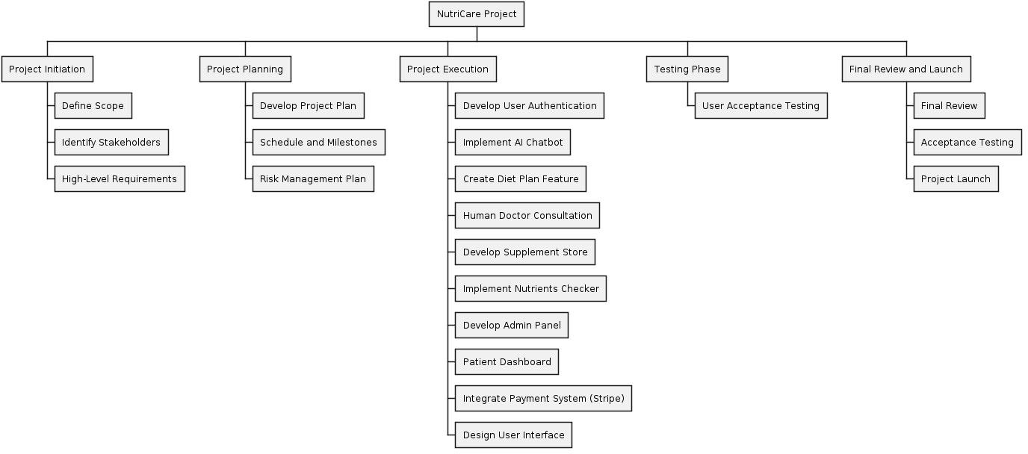

*Figure1. 1 Work Breakdown Structure*

* + 1. Gantt chart:

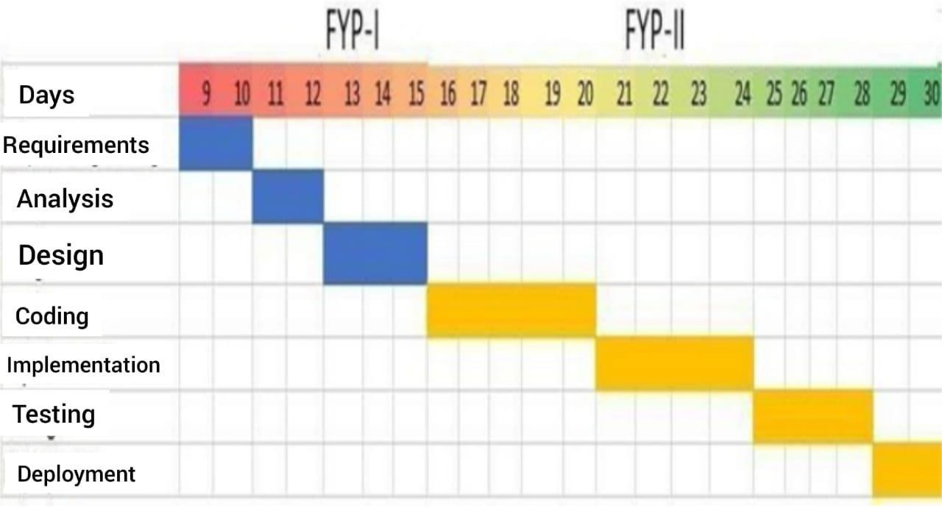

*Figure1. 2Gantt chart*

* + 1. Team Members:

|  |  |  |
| --- | --- | --- |
| **Name** | **Skills** | **Description** |
| Abdullah Hassan | Full Stack Developers | Handle Whole Project Solo |

*Table1. 1 Team Members*

#### Report Outline:

The NutriCare project documentation follows a structured outline to ensure clarity and comprehensiveness.

Project Initiation includes defining the project's scope, identifying key stakeholders, and outlining high-level requirements. Project Planning involves developing a detailed project plan, establishing a schedule with milestones, creating a budget plan, and developing a risk management plan.

Project Execution covers several components: implementing secure user authentication, developing an AI-powered chatbot for nutritional queries, designing personalized diet plans, integrating chat with human doctors, creating an online supplement store,

developing a tool to check food nutrients, creating a backend admin panel, designing a patient dashboard for health tracking, implementing a secure payment system with Stripe, and ensuring a user-friendly and interactive user interface.

The Testing Phase involves conducting unit, integration, and user acceptance testing, followed by fixing any identified bugs and making necessary improvements.

The Final Review and Launch phase includes performing a final review, conducting acceptance testing, and officially launching NutriCare.

# CHAPTER 2

# SYSTEM REQUIREMENTS AND SPECIFICATIONS

#### Purpose:

The purpose of NutriCare is to provide a comprehensive platform for nutritional consultation and aid, combining the capabilities of generative AI and web technologies. NutriCare aims to simplify the process of accessing reliable nutritional information, personalized diet plans, professional health consultations, and essential supplements, all within a single, user-friendly interface. By integrating various features such as an AI chatbot, nutrient checker, and human doctor consultations, NutriCare seeks to empower users to make informed health decisions and maintain a balanced diet, ultimately enhancing their overall well-being.

* + 1. Document Conventions:

When writing the SRS document for "FRIENDLY-TRANSLATOR" the following terminologies are used to make the document more effective and readable we used font:

* + - * Times New Roman
      * Line spacing: 2 line spacing
      * Font Size: 12pt
      * headings: 16pt
      * Headings are bold.

This document is intended to the audience and also for those End Users who really want to know for what purpose this application is developed for.

* + 1. Intended Audience:

People who want to improve their health and achieve their fitness goals

#### Overall Description

* + 1. Service Perspective:

NutriCare is a comprehensive nutritional consultation and aid platform designed to simplify the process of maintaining a healthy lifestyle and managing nutrition effectively. The platform utilizes generative AI and web technologies to offer users a holistic solution for their nutritional needs. NutriCare provides a seamless experience by combining various features, including AI-driven chatbots, human doctor consultations, a supplement store, and more, all accessible through a user-friendly interface.

* + 1. Service function:

The primary function of NutriCare is to provide accurate nutritional advice and support to users. This includes answering nutritional queries through an AI chatbot, offering personalized diet plans, enabling consultations with human doctors, facilitating the purchase of supplements and medicines, and allowing users to check the nutritional content of various foods.

* + 1. Product Functions:

###### Features**:**

* + - * Registration
      * login
      * AI-powered chatbot for nutritional queries
      * Customized diet plans based on user profiles and health goals
      * Access to professional medical advice through human doctor consultations
      * Integrated store for purchasing supplements and medicines
      * Tool for checking the nutritional content of foods
      * Admin panel for managing platform operations
      * Personalized dashboard for users to track health metrics and consultation history

###### UserFunction**:**

* + - * Registration
      * login
      * Editing user profiles
      * Book Appointment
      * Chat
    1. User Classes and Characteristics

##### Admin:

The administrator manages all functionality of NutriCare, including adding, editing, or deleting user accounts and chats.

##### Design and Implementation Constraints:

* + - * The device will have 8GB RAM.
      * Good quality Internet connection required.
      * Operating System Windows 10

##### Tools:

* + - * Development: Utilizes a combination of programming languages and technologies such as Python, JavaScript, HTML, CSS, and others.
      * Development Environment: Developed using web technologies and frameworks.
      * Integration: Integrates with third-party services and APIs for additional functionalities.
      * Deployment: Deployed on cloud-based platforms or servers for accessibility.Google Firebase
      * Editer : Vscode
      * Testing Tool : Postman
    1. Assumptions and Dependencies
       - Users must create an account and register via email verification.
       - Users must have a smartphone with at least Android 4.4 version.
       - Users must have internet access as NutriCare is an online platform.
       - Users are responsible for remembering their login credentials for accessing their accounts.

#### External Interface Requirements

* + 1. User Interfaces

NutriCare offers an intuitive and engaging user interface designed to enhance user experience. Users will find it easy to navigate through the application, understand the functionality of each feature, and interact seamlessly. Key user interface interactions include:

User can interact with following things:

* + - * Multi-language Support: Users can enjoy NutriCare in multiple languages, ensuring accessibility for a diverse user base.
      * Language Preference for Messaging: Users can send and receive messages in their preferred language, enhancing communication and understanding.

r

* + 1. Application interface:
* Vscode
* Python 3
* Django

#### System Features

* + 1. User registration

##### Description Priority

User registration is the initial step for new users to access NutriCare. It has the highest priority as it enables users to create their profiles and utilize the application's features.

##### Stimulus/Response Sequences:

* + - * Upon launching the application, users are prompted to provide profile data.
      * A registration form opens, allowing users to enter necessary information.
      * User data is stored securely in the database.
      * After registration, users are directed to the dashboard.

##### Functional Requirements

Users successfully register and gain access to the application.

* + 1. Login/logout

##### Description and Priority:

Authentication is required for users who are not logged in. Users can also log out if needed. This feature has the second-highest priority for user access and security.

##### Stimulus/Response Sequences

* Upon launching the application, users are prompted to log in.
* A login form opens, requiring users to input their credentials.
* User credentials are verified against existing data in the database.
* After authentication, users are directed to the dashboard.
* Logging out ends the user session.

##### Functional Requirements

Users can log in and log out securely.

* + 1. Change Profile:

##### Description and Priority

Users have the option to edit their profiles, including language preferences and biography. This feature addresses user preferences and has a medium priority.

##### Stimulus/Response Sequences

* + - * Users can edit their preferred language.
      * Edited information is stored in the database for future logins.
      * Users can also update their biography.
      * Updated profile information is securely stored in the database.

##### Functional Requirements

User must be register and logged in.

Registered and logged-in users can modify their profiles.

#### Other Nonfunctional Requirements

* + 1. Performance Requirements
       - NutriCare requires Secure Web Browser higher for optimal performance.
       - A stable internet connection is necessary for seamless usage.
    2. Safety Requirements

Only authorized users can access the application through secure login mechanisms. User data is encrypted before storage to safeguard against unauthorized access or data breaches.

* + 1. Software Quality Attributes
       - Privacy and security are paramount, ensuring user data confidentiality.
       - NutriCare is available 24/7 for user accessibility.
       - Component design optimizes performance even during peak usage.
       - The application is designed to be error-free and reliable.
       - Data security measures ensure the integrity and confidentiality of user information.
       - NutriCare offers a user-friendly interface for easy navigation and usage

#### Other Requirements

User information is stored in a database, with each user associated with a unique email ID for data organization and retrieval.

# CHAPTER3 USECASE ANALYSIS

#### Use Case Model:

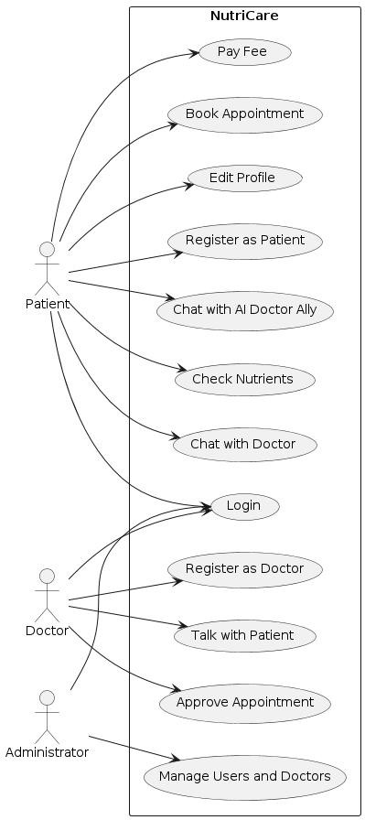

*Figure3. 1 Use Case Model*

#### Detailed Analysis

##### Actors

Patient:

* + - Registers on the platform.
    - Logs in and logs out.
    - Books appointments with doctors.
    - Pays fees for consultations or services.
    - Chats with doctors for medical advice.
    - Chats with the AI doctor (Ally) for nutritional guidance.
    - Checks the nutritional content of various foods.
    - Edits their profile information.

Doctor:

* + - Logs in and logs out.
    - Approves appointments requested by patients.
    - Chats with patients to provide medical consultations.
    - Registers as a doctor on the platform.

Admin:

* + - Logs in and logs out.
    - Manages user accounts (adding, editing, deleting patients).
    - Manages doctor accounts (adding, editing, deleting doctors).
    - Use Cases

Register:

* + - Both patients and doctors can register on the NutriCare platform.
    - Required for accessing other features.

Login/Logout:

* + - Essential for secure access to the system.
    - Validates user credentials and manages sessions.
    - Book Appointment:
    - Patients can book appointments with available doctors.
    - Triggers doctor notification for approval.

Pay Fee:

* + - Facilitates payments for booked appointments or other services.
    - Integrated with a secure payment system.

Chat with Doctor:

* + - Patients can initiate and engage in chat sessions with doctors.
    - Enables real-time medical consultations.

Chat with AI Doctor Ally:

* + - Patients can ask nutritional questions and receive automated advice.
    - Uses AI to provide personalized nutritional guidance.

Check Nutrients:

* + - Patients can check the nutritional content of various foods.
    - Provides detailed information to help with diet planning.

Edit Profile:

* + - Patients can update their profile information,

including personal details and preferences.

Approve Appointment:

* + - Doctors can approve or decline appointment requests from patients.

Talk with Patient:

* + - Doctors engage in chat sessions with patients.
    - Provides real-time medical advice and consultation.

Register as Doctor:

* + - Allows new doctors to register and join the platform.
    - Admin reviews and approves new doctor registrations.

Manage Users:

* + - Admin can add, edit, or delete patient accounts.
    - Ensures proper management of user data and access.

Manage Doctors:

* + - Admin can add, edit, or delete doctor accounts.
    - Ensures proper management of doctor data and access.

# CHAPTER 4 SYSTEM DESIGN

## System Design

The system design describes the system requirement, operating environment system and subsystem architecture, files and database design, input format, output layout, user interface, detailed design processing logic, an external interface.

#### Architecture Diagram

We divided system architecture in three-part application, services & authentication and database, As Shown in the figure.

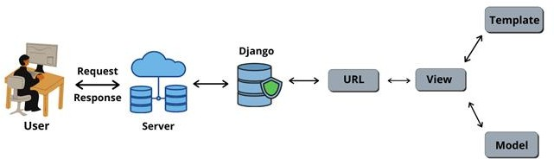

*Figure4. 1 Architecture Diagram*

#### Domain Model:

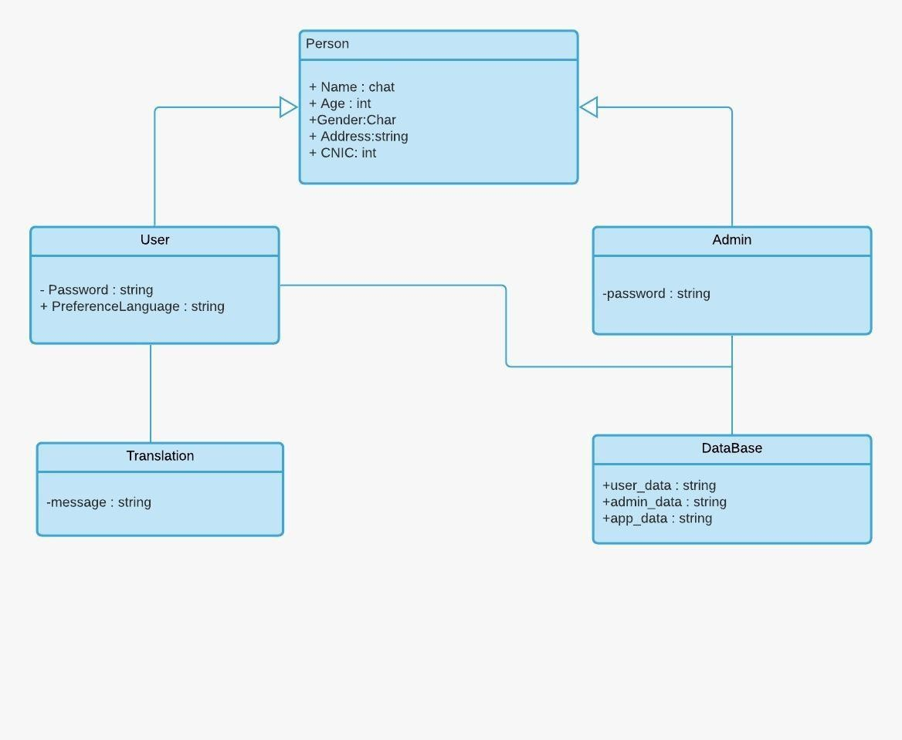

*Figure4. 2 Domain Model*

#### Entity Relationship Diagram :

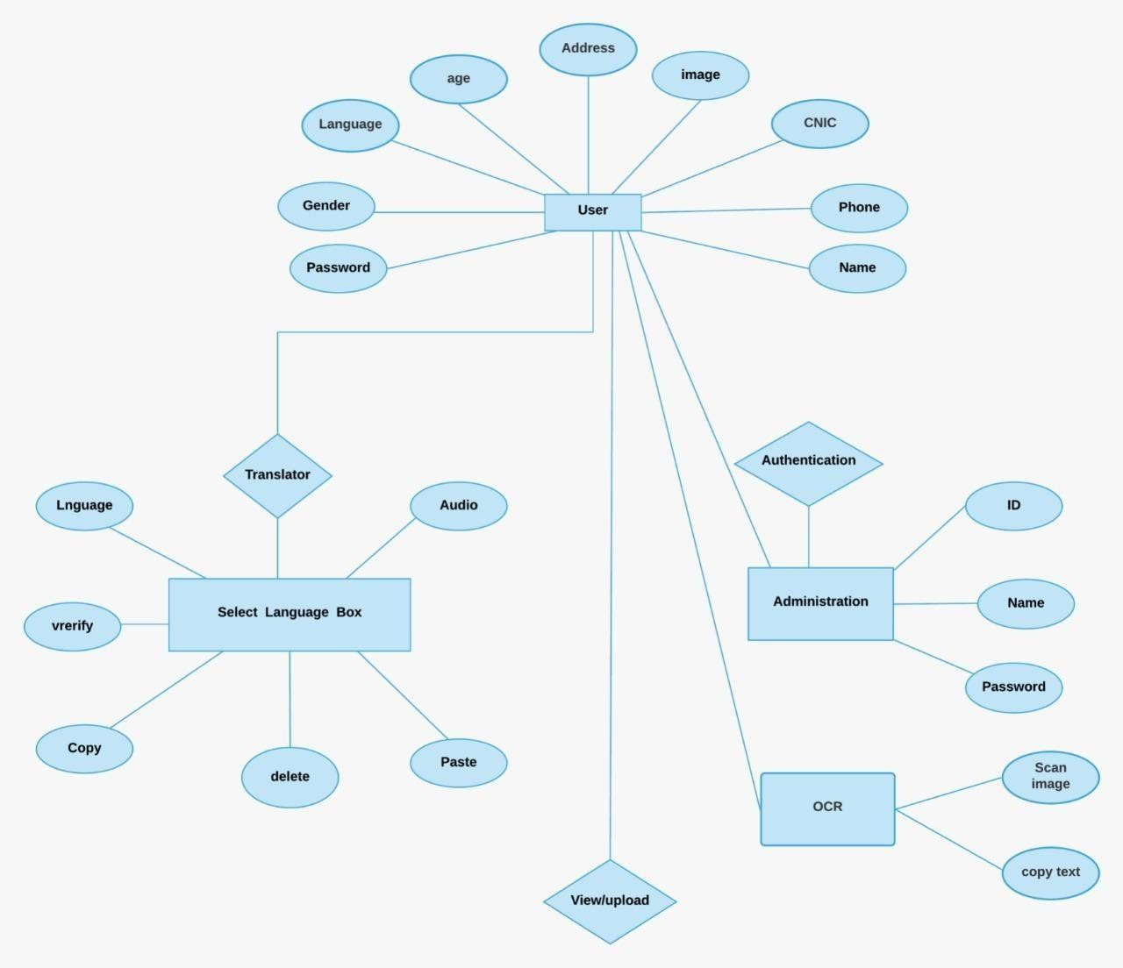

*Figure4. 3 Entity relationship diagram*

#### Class Diagram

*Figure4. 4 Class Diagram*

#### Sequence / Collaboration Diagram:

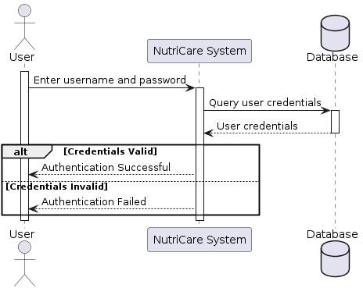

*Figure4. 5 Sequence Diagram (Authentication)*

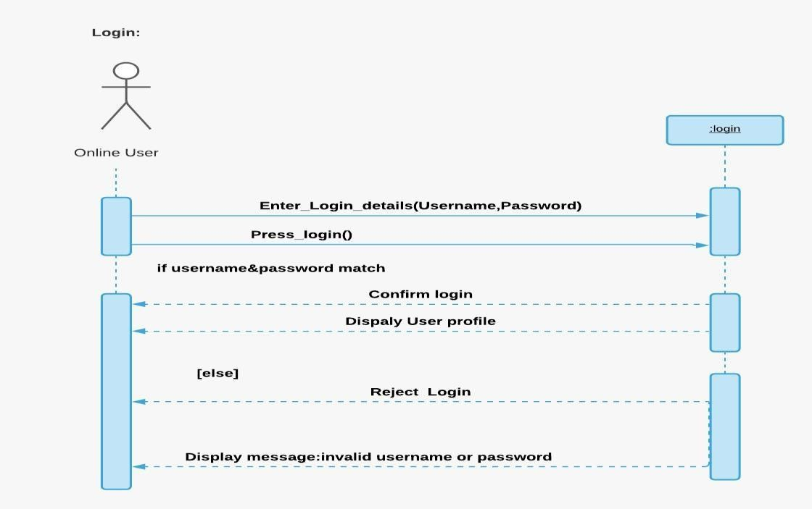

*Figure4. 6 Sequence Diagram (login)*

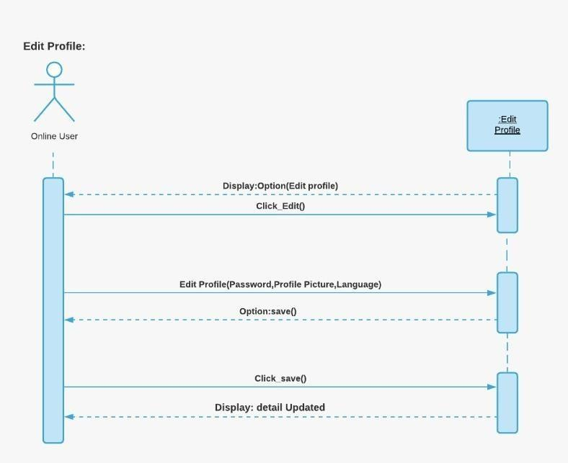

*Figure4. 7 Sequence Diagram (Edit profile)*

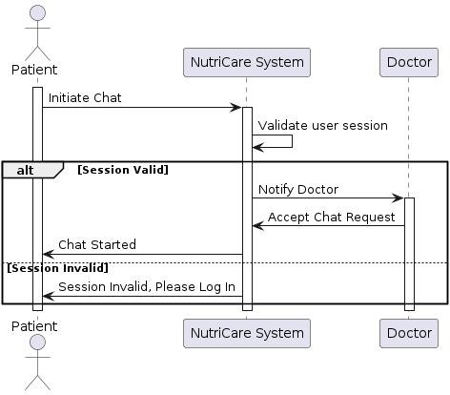

*Figure4. 8 Sequence Diagram (Chat)*

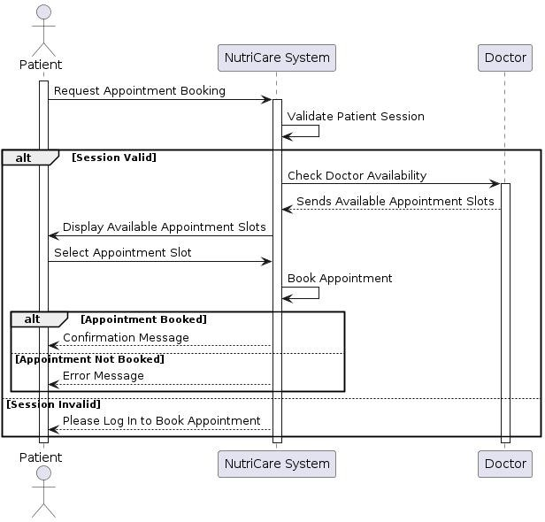

#### Activity Diagram:

**Fig 4.7**

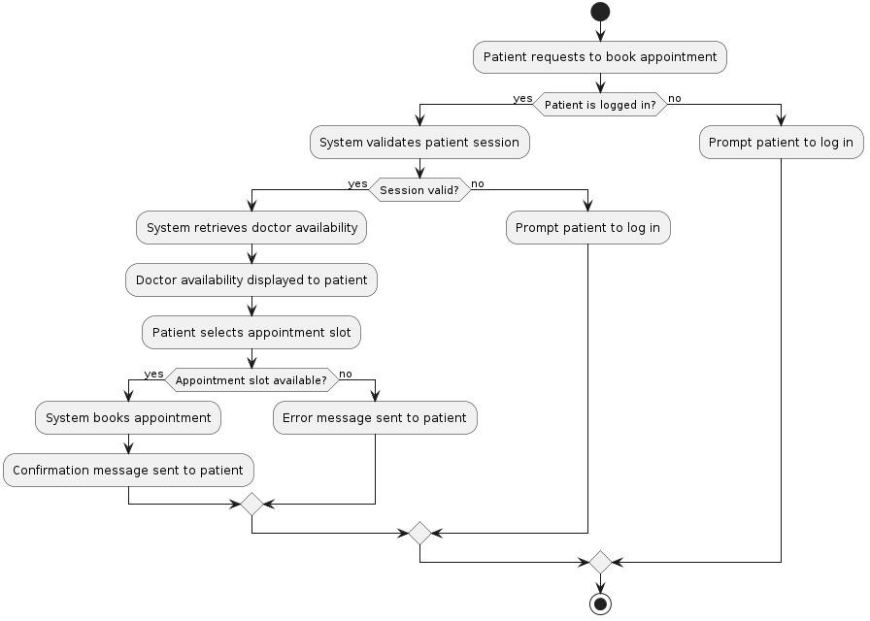

*Figure4. 10 Activity Diagram*

#### State Transition Diagram

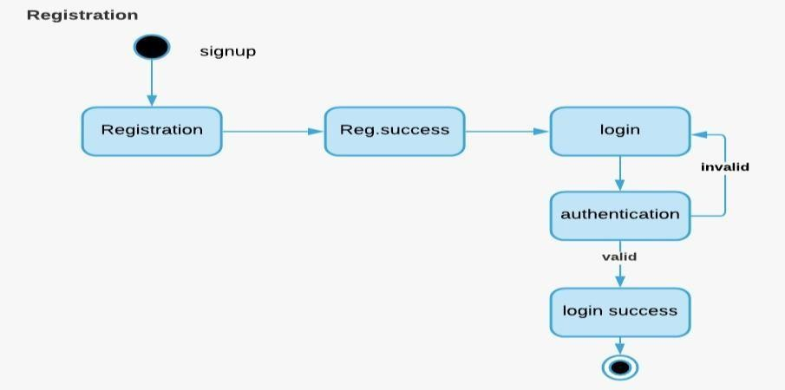

*Figure4. 11 State Transition Diagram (Registration)*

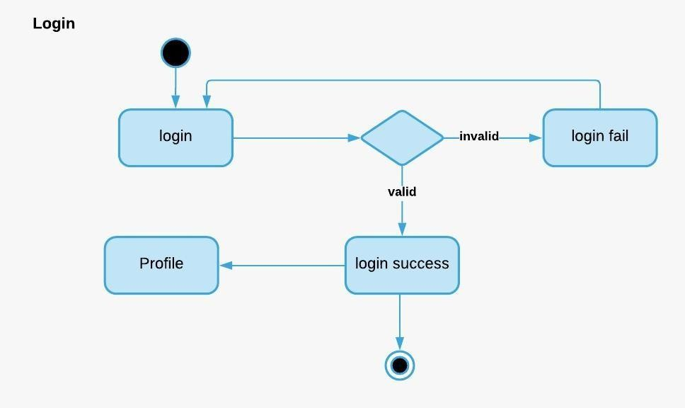

*Figure4. 12 State Transition Diagram (Login)*

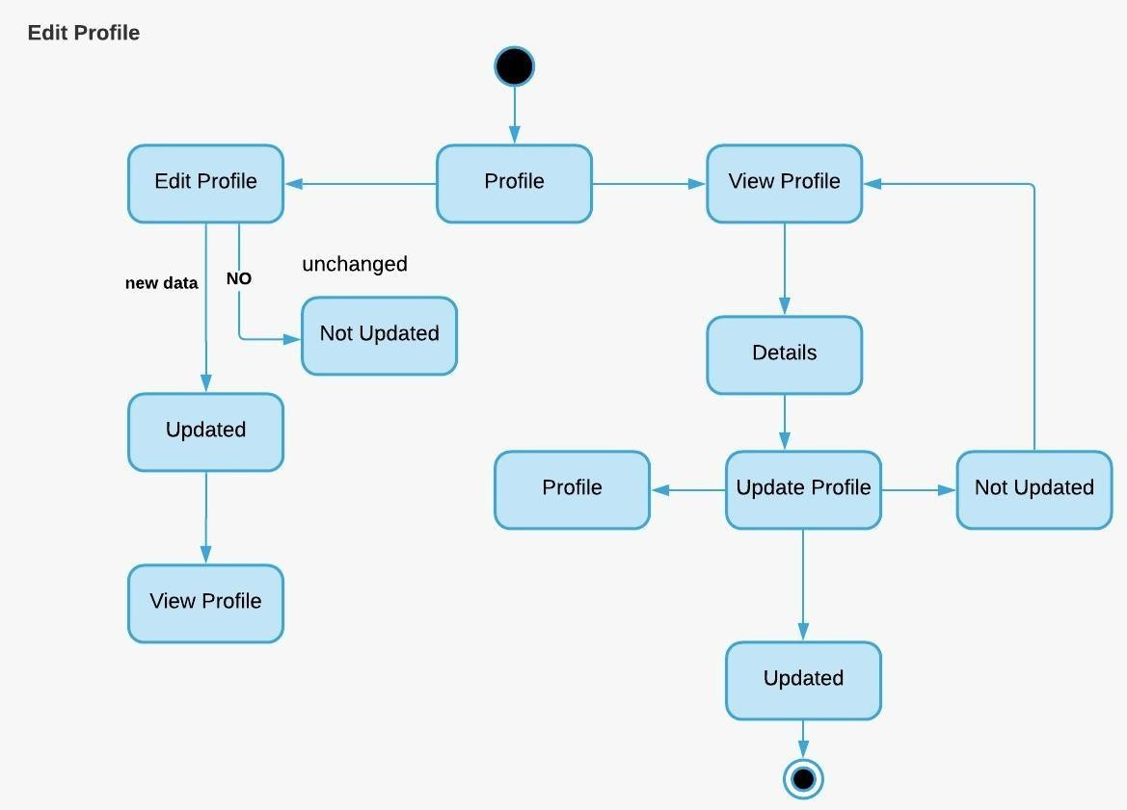

*Figure4. 13 State Transition Diagram (Edit Profile)*

CHAT BOX:

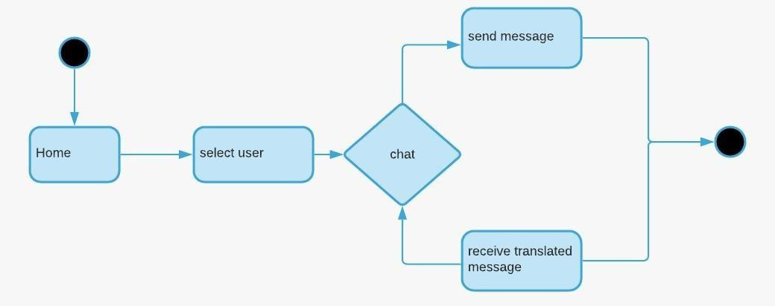

*Figure4. 14 State Transition Diagram (Chat Box)*

#### Component Diagram:

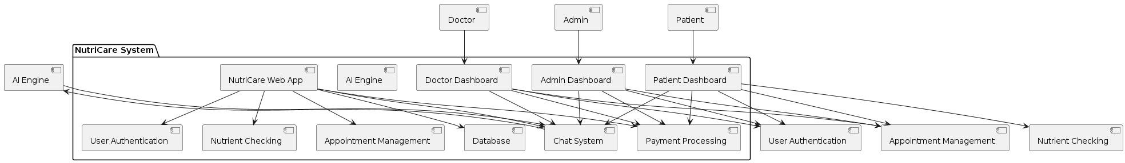

**Figure 4.16:** Component Diagram

*Figure 4. 16 Component Diagram*

#### Interference:

* + 1. **Landing Pages:**

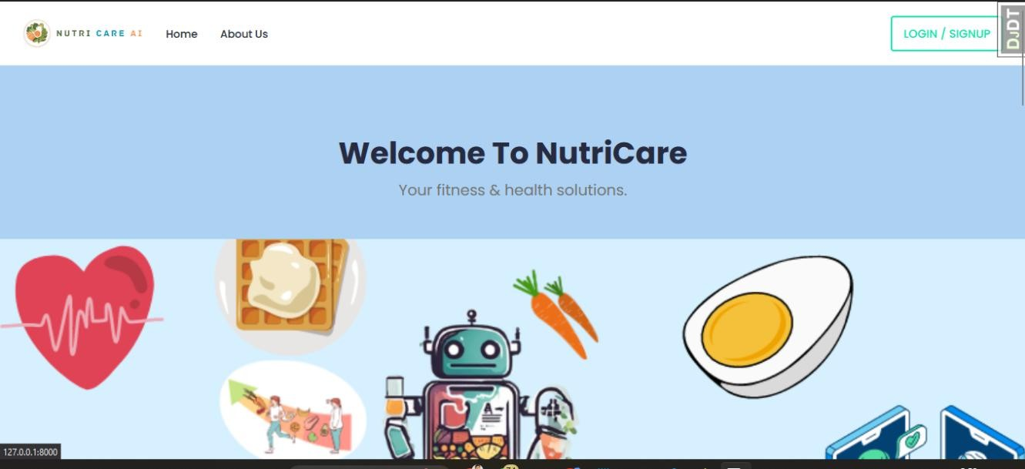

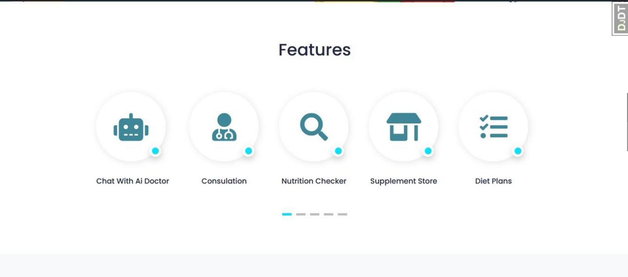

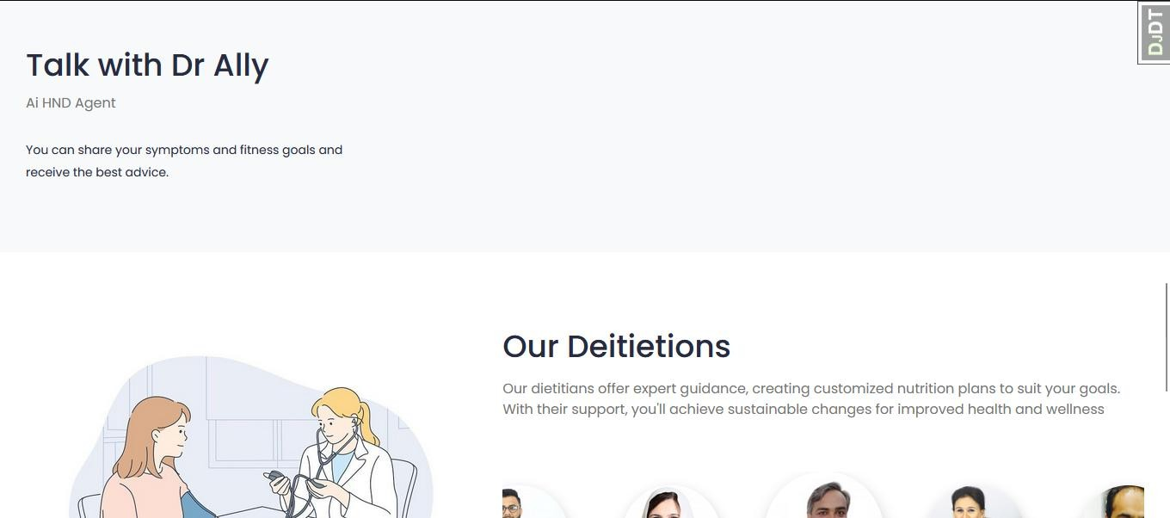



**Login as Patient:**

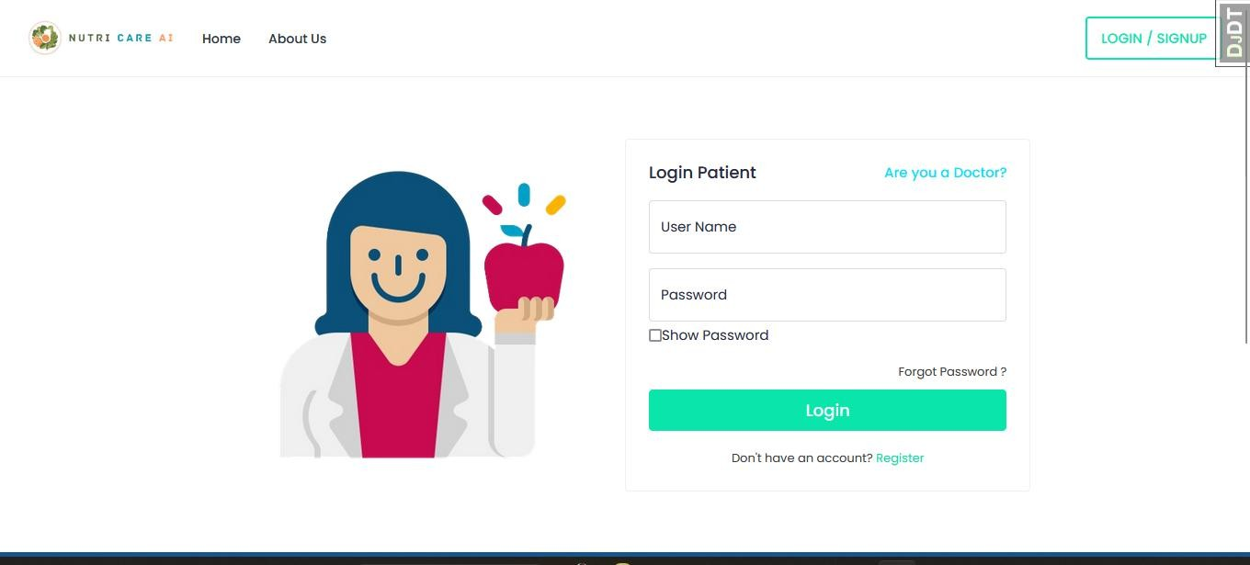

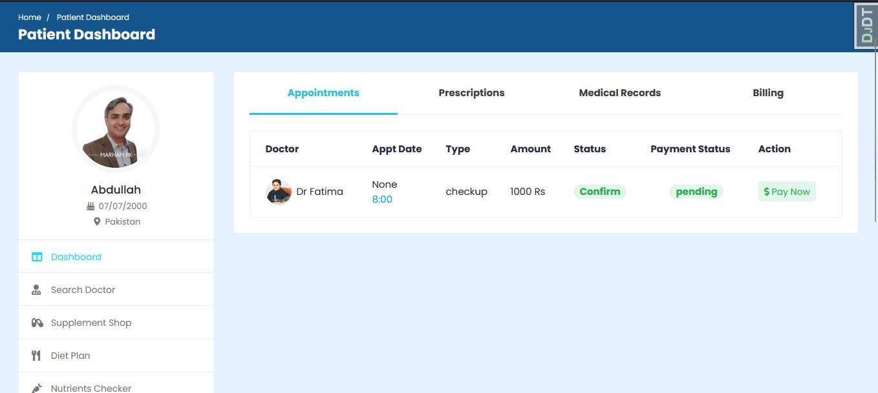

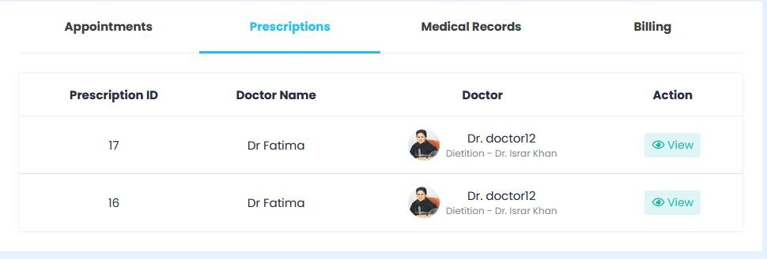

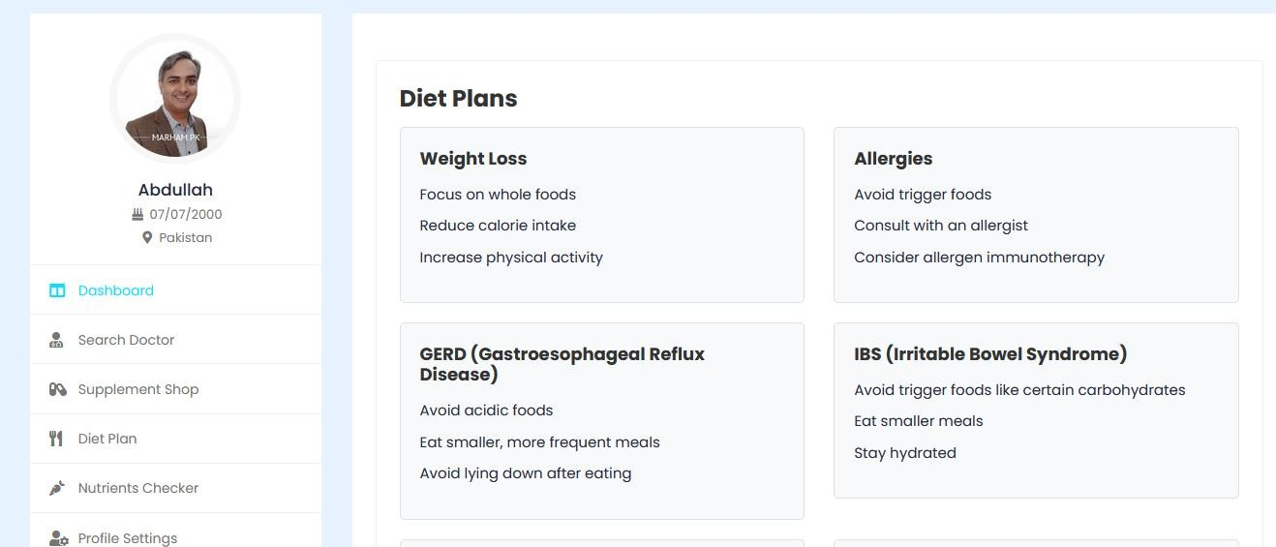

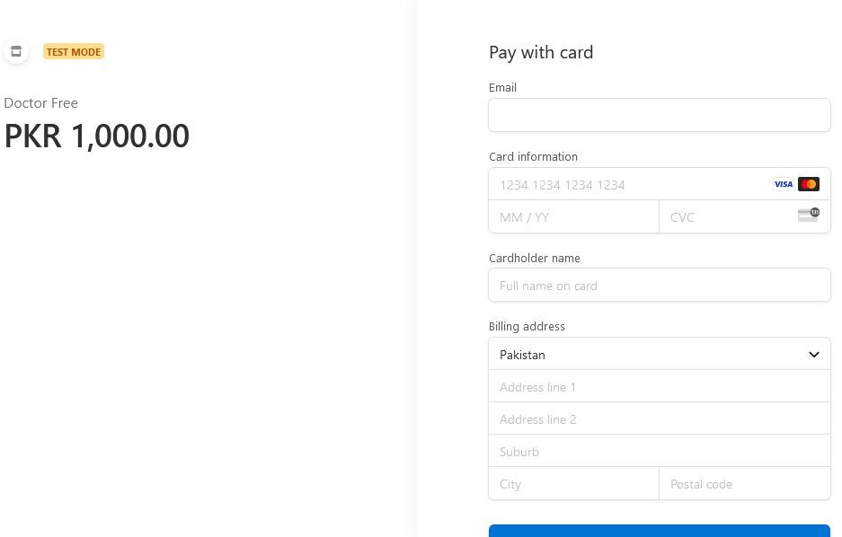

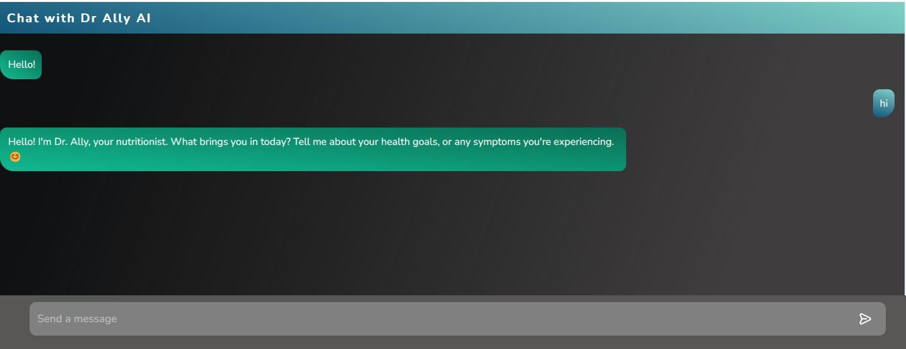

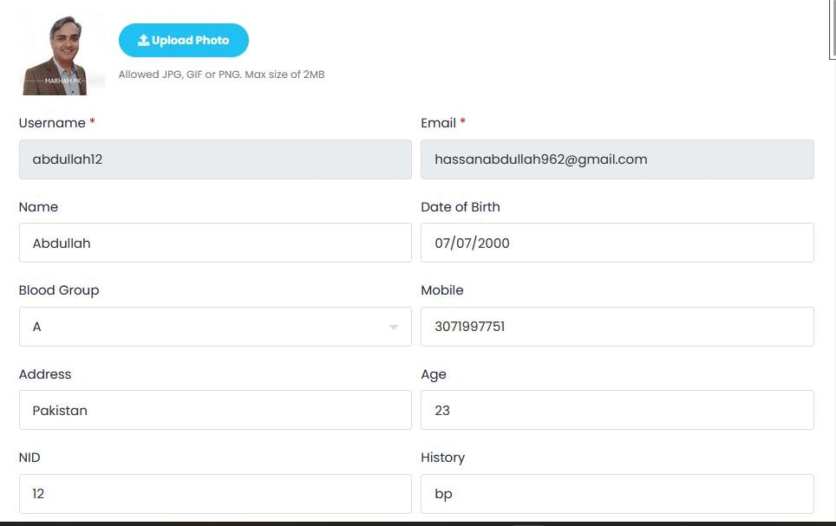

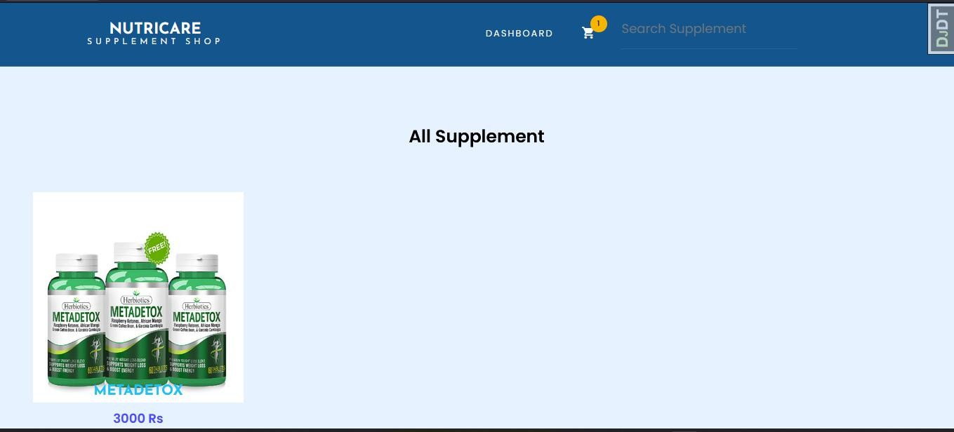

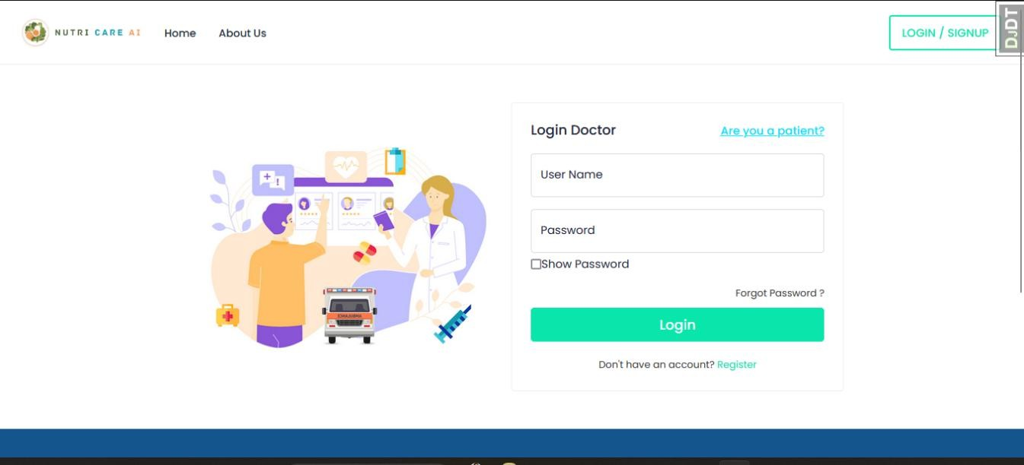

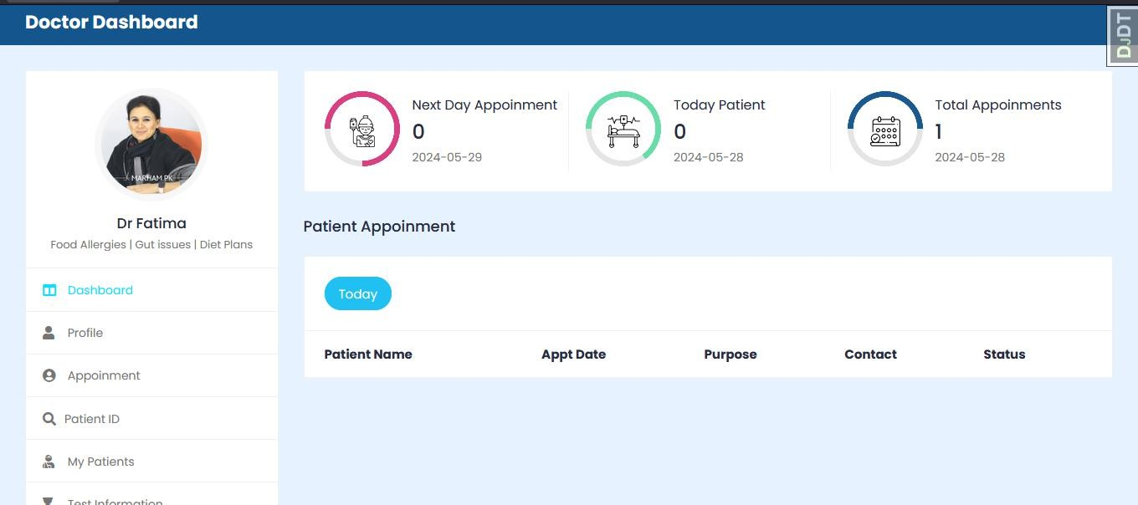

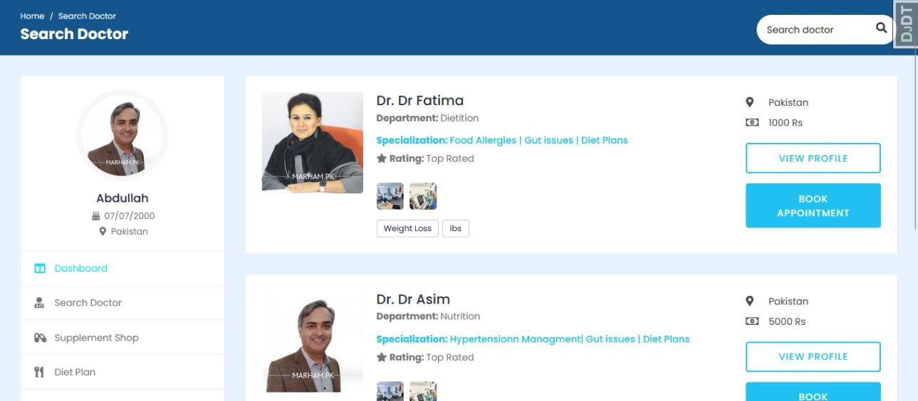

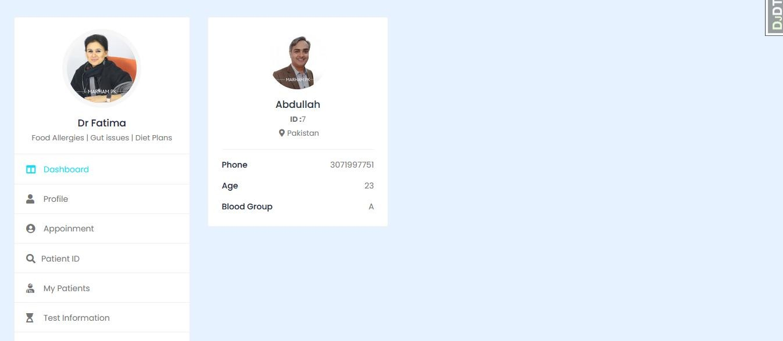

45

# CHAPTER 5 IMPLEMENTATION

#### Components, Libraries and stubs:

##### Libraries

Libraries are a collection of diverse functions that are utilized in the creation of a project to make the various functions easier to perform. The functions are linked to the libraries, making it simple to conduct tasks across many activities. A list of the many libraries used in our project is provided below.

* + - Pillow
    - Dcertifi==2023.7.22
    - charset-normalizer==2.0.11
    - Django==4.1.13
    - django-debug-toolbar==3.6.0
    - django-environ==0.9.0
    - django-widget-tweaks==1.4.12
    - djangorestframework==3.13.1
    - idna==3.7
    - Pillow==10.3.0
    - python-dateutil==2.8.2
    - python-decouple==3.6
    - pytz==2021.3
    - reportlab==3.6.13
    - requests==2.31.0
    - six==1.16.0
    - sslcommerz-lib==1.0
    - urllib3==1.26.18
    - virtualenv==20.14.1
    - whitenoise==6.2.0
    - widgetsnbextension==3.5.2
    - xhtml2pdf==0.2.8
    - asgiref==3.7.2
    - certifi==2023.7.22
    - charset-normalizer==3.2.0
    - django-mathfilters==1.0.0
    - idna==3.4
    - sqlparse==0.4.4
    - tzdata==2023.3
    - urllib3==2.0.4

#### Deployment Environment

* Vscode
* Python 3
* SQLite 3
* Database Server

#### Tools and Techniques

* Python
* Django
* Gemma 2b
* SQLite
* Stripe
* Html
* CSS
* Bootstrap
* JavaScript

#### Best Practices / Coding Standards

* Code should not have any trailing whitespace to avoid creating unnecessary diff issues.
* Function and classes are always commented on showing expected input and output
* GUI should be user-friendly
* Let photos say what you can’t say
* Document everything
* Demand for Feedback

# CHAPTER6

# TEST AND EVALUATION

#### Testing and Evaluation

Testing is a procedure for detecting problems in a program. We execute a simulation test on the system to ensure that any errors or bugs are not there. Various scenarios and forms of testing will be used to determine whether or not the system is functioning properly. If any faults are discovered throughout the testing, provide a solution to the errors. In this chapter, we cover the entire system testing and assessment process, including how to use the system and what work each feature has completed.

#### Use Case Testing

Various scenarios, such as user and admin functionality, are being tested throughout this session.

Use Case Testing is a software testing technique that helps to identify test cases that cover entire system on a transaction-by-transaction basis from start to end. Test cases are the interactions between users and software application. est **cases** based on use cases and are referred as scenarios. Capability to identify gaps in the system which would not be found by testing individual components in isolation. Very effective in defining the scope of acceptance tests.

##### Main success scenario:

|  |  |  |  |
| --- | --- | --- | --- |
| **Actor:** | **Admin** | |  |
| **No.** | | **Steps** | **Description** |
| 1 | | Login as admin | Login to system with correct username and password  System will redirect to next page |
| 2 | | Add a user | Add a new user to the database to allow him to use services of app |
| 3 | | Check system | Check the whole system at anytime |
| **Actor:** | **User** | |  |
| **No.** | | **Steps** | **Description** |
| 1 | | Registration | To get access to the system a user must get registered |
| 2 | | Login | Login to the system with correct name and password System will redirect to next page |
|  | | Logout | Logout success with press logout button System will redirect to login page |

*Table6. 1 Use Case Testing-01*

|  |  |  |
| --- | --- | --- |
| **Actor: Vendor** | | |
| **No.** | **Steps** | **Description** |
| 1 | Login as a user | Login to system with correct username and password System will redirect to next page |
| 2 | Add a text | Add a new text |
| 3 | Update Delete profile | Check and change the profile at anytime |
| 4 | Add edit and Remove any text or voice | User can delete any text or voice |

*Table6. 2 Use Case Testing-02*

## Extensions (Errors):

|  |  |  |
| --- | --- | --- |
| **No.** | **Step** | **Description** |
| **1-a** | Login failed | Login failed if admin enter wrong username System will display an error message |
| **1-b** | Login failed | Login failed if admin enter wrong password. System will display an error message |
| **2** | Registration failed | Registration will failed if a new user don’t follow the rules.System will display an error message |
| **3-a** | Login failed | Login failed if customer enter wrong username System will display an error message |
| **3-b** | Login failed | Login failed if customer enter wrong password. System will display an error message |
| **4-a** | Login failed | Login failed if Vendor enter wrong username System will display an error message |
| **5-b** | Login failed | Login failed if Vendor enter wrong password. |

*Table6. 3 Use case testing extension*

#### Boundary value analysis

Boundary testing is a type of testing that takes place between a starting point and the extreme ends of a range of input values, or between partials of input values.

##### Login username

* + - A person's username must be correct and unique when entering it in the text field during login.
    - If the username is incorrect, the system will block the user from accessing the current page.

##### Login password

* + - The username entered in the text field during login must be accurate.
    - If the username is incorrect, the system will block the user from accessing the current page.

##### Text fields:

* + - The system must allow only correct text in all text fields.
    - The user must add only the information that is required and brief.
    - Name, gender and preference language are examples of text fields.

##### Numeric fields:

* + - The numeric fields must accept only numbers
    - Numeric fields are mobile number and CNIC.

##### Alphanumeric field:

* + - The alphanumeric fields must accept alphabet , character and numbers
    - Alphanumeric fields are password and address

#### Performance testing:

##### Test case title: System response time testing

|  |  |  |
| --- | --- | --- |
| **Test type** | **Performance testing** | **Test result** |
| Required performance | The required response time of the  system is less than 2 seconds |  |
| System performance | The actual performance response time is  2 seconds. | Test passed |

*Table6. 4 Performance Testing 01*

##### Test case title: Activity load time testing

|  |  |  |
| --- | --- | --- |
| **Test type** | **Performance testing** | **Test result** |
| Required performance | The required page load time of the  system is less than 3 seconds |  |
| System performance | The actual page load time is 2 seconds. | Test passed |

*Table6. 5 Performance Testing 02*

##### Test case title: Huge number of users

|  |  |  |
| --- | --- | --- |
| **Test type** | **Performance testing** | **Test result** |
| Required performance | System should perform normally and  efficiently with a large number of users |  |
| System performance | System performed all activities normally  with a large number of users. | Test passed |

*Table6. 6 Performance Testing 03*

##### Test case title: Waiting time testing

|  |  |  |
| --- | --- | --- |
| **Test type** | **Performance testing** | **Test result** |
| Required performance | The average waiting time of the  system is less than 3 seconds |  |
| System performance | The actual performance response time  is 2 seconds in some circumstances. | Test passed |

*Table6. 7 Performance Testing 04*

##### Test case title: Connection establish time testing

|  |  |  |
| --- | --- | --- |
| **Test type** | **Performance testing** | **Test result** |
| Required performance | The connection must be established in  less than 2 seconds |  |
| System performance | The actual connection establishes time is about 1 second. | Test passed |

*Table6. 8 Performance Testing 05*

##### Test case title: Database send/get information time testing

|  |  |  |
| --- | --- | --- |
| **Test type** | **Performance testing** | **Test result** |
| Required performance | The system should save or retrieve data from database in less than 2 seconds. |  |
| System performance | The actual time system sends or gets information to database in 1 second. | Test passed |

*Table6. 9 Performance Testing 06*

#### Stress Testing:

Stress testing is a method of determining a system's stability and dependability. Stress testing is a technique for determining a system's ability to handle flaws and faults. Stress testing is a technique for evaluating a system's ability to handle errors under harsh conditions.

We overload our system and analyze its behavior in extreme settings to confirm that it behaves normally during stress. In bad conditions, the (Translator app) management system behaves regularly, and all of its features and functions work as expected.

Through this testing, we monitor our system and make sure our system

* + - System should save all data before crashing
    - Make sure the connection from server
    - If server no response, wait on login current page
    - The system should accurately display the deletion and updating of records.

#### Improvement:

As we all know, there is always room for improvement in every management system. The following are some basic changes that we should make in the future:

1. Physical count:

It is a good strategy to rely on inventory systems, but we should never completely rely on them. In addition, we should translate words into multiple languages.

1. App quality:

For use, quality is quite crucial. Always keep a close eye on quality control and never skimp on it. The higher the quality, the better.

1. System level:

Our system should not be clogged with too much data. We should only give the user with the most basic information. Otherwise, the user may feel perplexed and will be unable to use our app.

1. Add less known Languages:

Besides the top languages for translation, the software will have to provide accurate solutions to communicate with audiences who speak less known dialects**.**

## References:

* <https://www.marham.pk/>
* <https://docs.djangoproject.com/en/5.0/>
* <https://github.com/abdullah12-alt/NutriCareAi-FYP>
* <https://getbootstrap.com/docs/5.0/getting-started/introduction/>